STUDENT |  | GRADER | Total Score
 |  |  | Total Score
  I am submitting my own work, and I understand penalties will
  be assessed if I submit work for credit that is not my own.
   | Print Name |  | ID Number
   | Sign Name |  | Date
  # | Points | Score
  1 | 8
  2 | 6
  3 | 4
  4 | 3
  5 | 6
 |  |  | Weeks late
 |  |  | Adjusted Score
 |  |  | Adjusted Score
  Estimated Work Hours
  1 | 2 | 3 | 4 | 5 | 6 | 7 | 8 | 9 | 10
  1 | 2 | 3 | 4 | 5 | 6 | 7 | 8 | 9 | 10
  Overall Weight
Adjusted Score:
Deduct 20% from score for each week late

Problem 1: Obtain and read the board’s reference manual, paying close attention to the Power Supply and Configuration Sections. Complete the following.

How many LED’s are on the board? _____ Are they illuminated with a logic ‘1’ or ‘0’? ______

How many pushbuttons on the board? _____ Do they output logic ‘1’ or ‘0’ when pressed? ______

How many slideswitches on board? _____ Do they output constant logic levels (yes or no)? ___

Which signals turn on the seven-segment displays? ______ ______ ______ ______

Problem 2: Obtain and print the board schematic, and identify the following components by circling and labeling them, both in the schematic and on the photo below. Write the reference designator or part value in the spaces following the components. See Appendix 1 if you have a Nexys3 board.

- Pushbutton number 2 Reference Designator: ______
- 3.3V voltage regulator Reference Designator: ______
- PS/2 Port Reference Designator: ______
- The FPGA Reference Designator: ______
- The Platform Flash ROM Reference Designator: ______
- Oscillator: Basys2 “MCLK”;
Nexys2 “GCLK0” Reference Designator: ______
- The Mode Select jumper Reference Designator: ______
- Any LED Reference Designator: ______
- VGA Port Reference Designator: ______
- Capacitor: Basys2 C30; Nexys2 C102 Capacitor’s value? ______
- Resistor: Basys2 R56; Nexys2 R11 Resistor’s value? ______

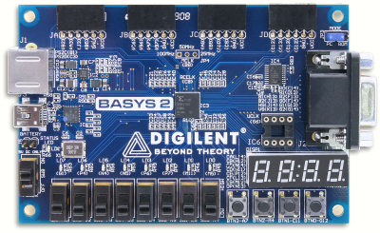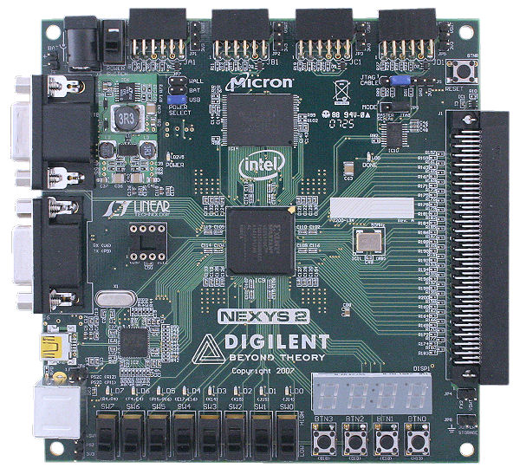
Problem 3: What must you do to ensure USB power is used with the board?

About how much current will your board use under nominal conditions?

How much power will your board consume under nominal conditions?

How much energy will your board use (assuming USB power) in one hour of use?

Problem 4: What file type is transferred to the board during configuration?

What software tool is used to transfer a configuration file to the board?

Problem 5: Perform a basic inspection and test of the board.

  - Inspect the board and note any components that appear to be missing, damaged, or otherwise compromised. When inspecting the board, you can compare it to the picture on the Digilent website (or the picture in this document).
  - Set the programming mode jumper(s) to configure the board from the on-board ROM.
  - Apply power to the board, and ensure the power-on LED illuminates and glows brightly.
  - The automated test, stored in the on-board Flash ROM at manufacturing time, will automatically configure the FPGA with a circuit that can be used to test all circuits. If the automated test does not automatically load, the ROM image may have been overwritten. Obtain the appropriate “Board Verification Project” from the Digilent website, and re-load the Flash ROM (see Appendix A the Lab Project 2 document for a brief tutorial on using Adept).
  - Alternatively, you can use the automated test tab in Adept to configure the board with a test circuit to drive all the on-board devices.

Complete the check-off sheet below. If any item has been checked “N” in the table, consult the lab assistant for help in resolving the issue.

All required components present (board, programming cable, etc.) | Y | N
Visual inspection reveals no obvious problems | Y | N
“Power On” LED glows brightly when power supply attached | Y | N
All segments on all seven-segment digits are functional | Y | N
All slide switches function correctly by illuminating/extinguishing LEDs | Y | N
All LED’s illuminate properly | Y | N
All pushbuttons function correctly | Y | N

Appendix 1: Nexys3 reference designators and photo.

- Pushbutton number 2 Reference Designator: ______
- 3.3V voltage regulator Reference Designator: ______
- USB HID Port Reference Designator: ______
- The FPGA Reference Designator: ______
- The non-volatile serial PCM Reference Designator: ______
- Oscillator “GCLK0” Reference Designator: ______
- The Mode Select jumper Reference Designator: ______
- Any LED Reference Designator: ______
- VGA Port Reference Designator: ______
- Capacitor C200 Capacitor’s value? ______
- Resistor R84 Resistor’s value? ______

